 | Come Join Us for  LT24  Orlando, Florida, USA  August 10-17, 2005

You Are Invited!

The Exhibition Committee for the 24th International Conference on Low Temperature Physics (LT24) invites your organization to exhibit at LT24 scheduled for August 10 through 17, 2005 at the Hilton in the Walt Disney World Resort located in beautiful Orlando, Florida. This prestigious event is being held in the United States for the first time in twelve years and attendance by over 1,400 low temperature researchers and scientists is expected.

The LT24 Exhibition will consist of manufacturers, service providers, and publishers related to low temperature studies and will run in conjunction with the opening three days of the technical conference.

Don’t miss this exceptional opportunity to present your company’s latest products, services and techniques in this pleasurable Central Florida setting.

The LT24 Exhibition and all technical sessions will be held at the same facility. In order to assure maximum exposure for your company and value for your investment, the exhibit hall will be the site for all poster sessions, refreshment breaks and the daily afternoon “Beer Garden”.

Show Hours  Thursday, August 11, 2005  10:00 a.m. – 7:00 p.m.  (Includes afternoon “Beer Garden” from  4:00 p.m. – 7:00 p.m.)  Friday, August 12, 2005  10:00 a.m. – 7:00 p.m.  (Includes afternoon “Beer Garden” from  4:00 p.m. – 7:00 p.m.)  Saturday, August 13, 2005  9:00 a.m. – 1:00 p.m.  Move-in Hours:  Wednesday, August 10, 2005  9:00 a.m. – 5:00 p.m.  Dismantle:  Saturday, August 13  1:00 p.m. – 4:00 p.m. | Benefits to Exhibitors  - One Complimentary Full Conference Registration, which includes admittance to exhibit hall, all technical sessions and social events.  - One complimentary Exhibit Only Registration, which includes admittance to the exhibit hall and social events.  - Pre- and post-conference listing on the LT24 web site with a hyperlink to your company’s homepage.  - Company listing in the LT24 Conference Program Book.  - All poster sessions, refreshment breaks and afternoon “Beer Gardens” will be held in the exhibit hall.  - Special advertising and sponsorship opportunities. *Please see web site for more information.

Booth Rental Rates  10’ x 10’ Booth = $1,800  All booths will be 10’ wide by 10’ deep. Each booth will be equipped with 3’ high fabric side rails, an 8’ high fabric backwall and one 7” x 44” one-line company ID sign. The Exhibit hall is carpeted.  *Please see application form for payment options.  Exhibitor Registration  Each 10’ x 10’ booth purchase includes one Full Conference registration and one Exhibit Only registration. Full Conference registrants are granted access to all technical sessions, the exhibit hall and all social events. Exhibit Only registrants are granted access to the exhibit hall and social events only.  *Additional Full Conference and Exhibit Only registrations may be purchased for other personnel.  Assignment of Booth Space  Exhibit space will be assigned on a first-come, first-served basis until spaces are filled. Payments for booths must be received in full by June 1, 2005. Applications will not be processed without full payment.  Please select your preferred booth from the floor plan provided and indicate selection on exhibitor application. Please also indicate which companies, if any, you wish to avoid as neighbors. Booth spaces will be assigned by June 10, 2005.  Decorator  Arata Expositions (formerly Echo Expo, Inc.) has been chosen as the official decorator for LT24. Arata will provide the exhibitor service kit, which will contain all necessary information for ordering services such as furniture and accessories, plants, audio/visual equipment, electrical and telecommunications services, etc. Service kits will be mailed and made available on the web site by June 10, 2005. | Tentative Conference & Activities Schedule  General Registration for Attendees  Wednesday, August 10 - 1:30 pm  Opening Reception *Host Opportunities  Wednesday, August 10 - 5:00 pm  Exhibitor Move-In  Wednesday, August 10 – 9:00 am - 5:00 pm  Opening Ceremony - London & Simon Awards  Thursday, August 11 - 9:00 am & 2:00 pm  Posters and Exhibitions  Thursday, August 11 - 10:00 am -7:00 pm  (Beer Garden 4:00 pm-7:00 pm) *Host Opportunities  Friday, August 12 - 10:00 am -7:00 pm  (Beer Garden 4:00 pm -7:00 pm) *Host Opportunities  Saturday, August 13 - 9:00 am -1:00 pm  Parallel Technical Sessions  Thursday, August - 11 am & 2:00 pm  Friday, August 12 - 11:00 am & 2:00 pm  Saturday, August 13 - 11:00 am & 2:00 pm  Monday, August 15 - 11:00 am & 2:00 pm  Tuesday, August 16 - 11:00 am & 2:00 pm  Half-Plenary Lectures  Friday, August 12 – 9:00 am  Saturday, August 13 - 9:00 am  Monday, August 15 – 9:00 am  Tuesday, August 16 - 9:00 am  Free Day-trip to Cape Kennedy  Sunday, August 14  Plenary Lectures/Closing Ceremony  Wednesday, August 17 - 9:00 am  Conference Banquet/Entertainment *Host Opportunities  Tuesday, August 16 - 7:30 pm

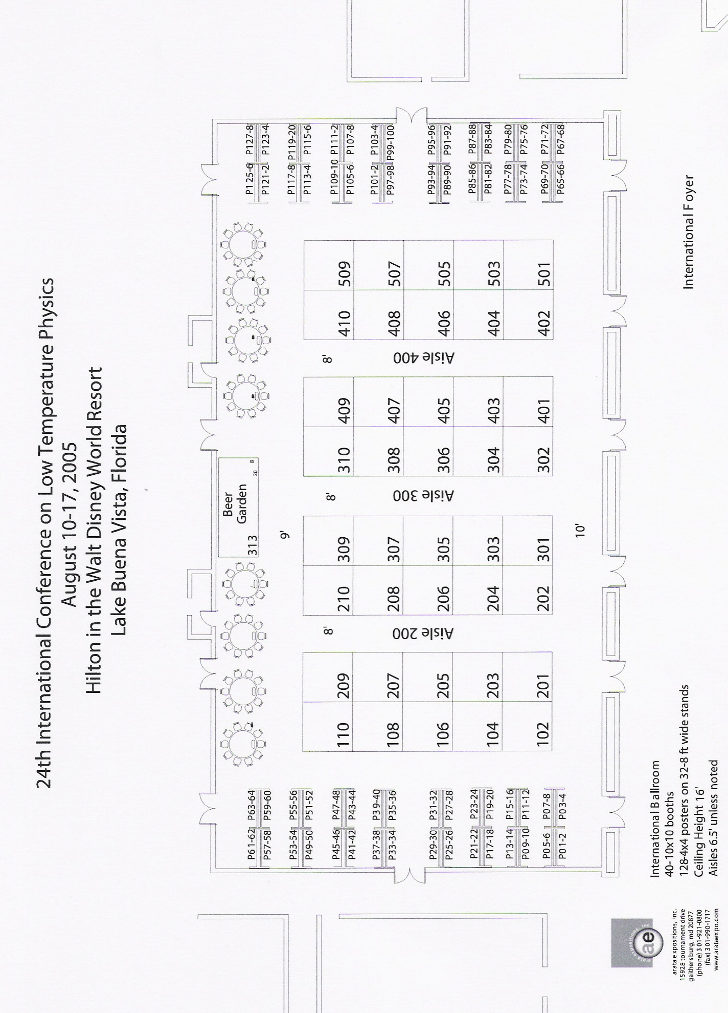

An Introduction to LT24

The Department of Physics at the University of Florida is pleased to host the 24th International Conference on Low Temperature Physics. This triennial conference has a rich tradition and is the main event sponsored by the International Union of Pure and Applied Physics (IUPAP) through its Commission C5 on Low Temperature Physics. The mandate of the conference is to promote the exchange of information and views among the members of the international scientific community in the general field of low temperature physics, and the main topics are broadly classified into five areas, namely:
- Quantum Gases, Fluids and Solids;
- Superconductivity
- Properties of Solids (including magnetic, mechanical, and thermal properties and phase transitions)
- Conduction Electrons in Condensed Matter (including localization, electron transport and mesoscopic phenomena); and
- Materials, Techniques and Applications

The Venue

The conference will be held at the Hilton in the Walt Disney World Resort in Lake Buena Vista, Florida, a suburb of Orlando, Florida. The Hilton is a four star, four diamond hotel and is an “official” hotel of Walt Disney World. The Hilton Hotel is located steps away from Downtown Disney, home of the Disney Marketplace, Pleasure Island, and Disney’s West Side. Please see our web site: www.phys.ufl.edu/~lt24 for special room rates ($99/night for 1 to 4 people) and reservations. Please reserve early, as the number of rooms in the Hilton are only half of what will be needed for conference.

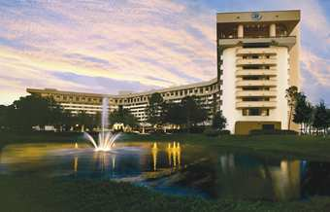

Looking forward to seeing you in beautiful Orlando, Florida!

