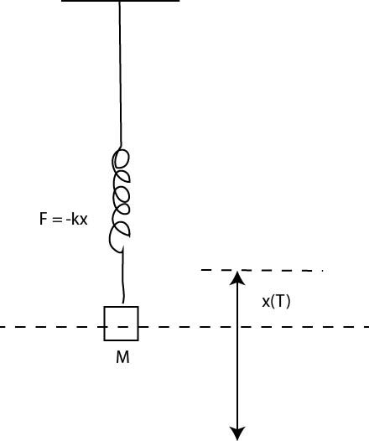**Lectures Nov 20-30.**

**Vibrations and Waves**

**Vibrating Spring**

Displace mass M from equilibrium.

Restoring force F=-kx starts oscillations

Displacement x(t) sine wave as function of time

X(t)= X0 sinωt ω=ft f=frequency in Hz or cycles per second, ω is in radians per second

KEY EQUATION:

 k is the spring constant

**Pendulum**

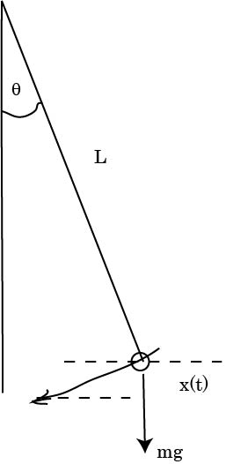Weight of bob =mg

Torque=mgLθ for small θ

Pendulum executes periodic motion with x(t) =x0 sinωt

Key equation

 DOES NOT DEPEND on MASS

**Waves on string**

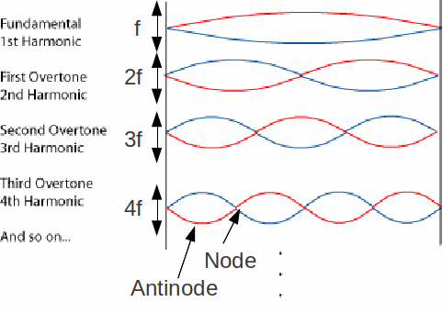

Each end is a NODE = no amplitude of vibration

L=λ/2, or λ or 3λ/2 etc.

That is L=nλ/2. n=1 is the fundamental, n= 2 is 2nd harmonic, n=3 is 3rd harmonic etc.

The frequency f=v/λ where v is the speed of propagation of the wave. E.g. v=331 m/s for sound in air.

Fundamental f= v/(2L)

**Waves in Pipes**

1. **One end closed**: that end must be a node and open end must be an anti-node

L= λ/4 or 3λ/4 or 5λ/4.

If v is given use f=v/λ to calculate frequencies

1. **Open at both ends**. Both ends are antinodes

L=λ/2 or λ or 3λ/2 etc

