Homework 1.) For PHY2061, Chaps. 25-26, Fall 2016
Due Aug. 30
Show work on problems to get credit – the answer is not enough.

1.) Make up one possible test problem (not too hard, not too easy) based on this homework, the lectures, and examples given in the book for Chaps. 25-26. Include a solution.

Chap. 25:
2.) Two electrons are held a fixed distance ‘r’ apart. m_{electron}=9.11 10⁻³¹ kg
One electron is released, and under the influence of the Coulomb repulsive force from the other electron moves away initially with an acceleration, a, = 9.8 m/s² (our old friend, ‘g’, the acceleration at the surface of the earth due to gravity.) What is ‘r’ to three significant figures? Include units.
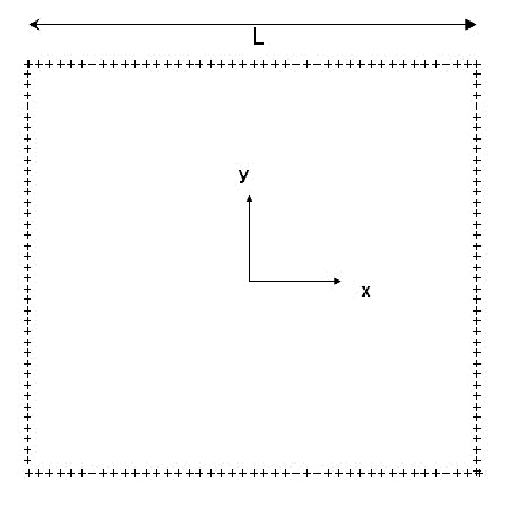
3.) We discussed in class doing the integral for a square plate of charge to find F_{Coulomb}. Suppose instead of a solid square we take (in analogy to the ring of charge done in the text starting on page 577) a square ‘frame’ of charge (see picture above) in the x-y plane (0,0 is in the center of the frame) where the sides are ‘L’ long with each side having charge ‘q’ uniformly distributed. Take a point a distance ‘z’ = L/2 above the center of this frame. Write down an expression (all integrals solved please) for the Coulomb vector force (F_{x},F_{y},F_{z}) on a test charge q₀ at this point L/2 above the center of the frame of charge.

- Two identical, small, conducting spheres are separated by a distance ‘r’, where ‘r’ is large with respect to the size of the spheres. The spheres originally have the same positive charge, and the force between them is F₁. ¼ of the charge of one sphere is now moved to the other sphere. What is the force between the spheres now, in terms of F₁ ? (Please show your work, not just an answer.)

- See Figure below. What is the electric field on the z-axis (which passes thru the charges shown – all charges are all on the z-axis) at a position ‘z’ above the origin, where z is >> d, the spacing between the charges? The charge distribution shown is made up of two dipoles, each with equal (but opposite in sign) charges q and –q and separation d for each dipole, and each dipole is aligned with its dipole moment pointing in the +z direction (unlike the quadrupole example we did in class on Thursday, where the two dipoles were arranged in opposite directions.)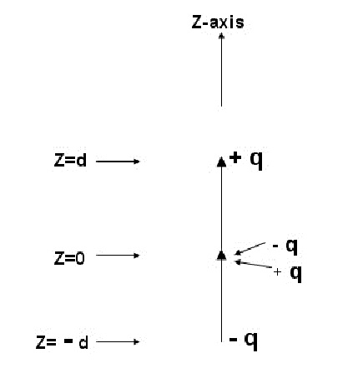

Points
10

