Homework 1, PHY4905, Spring 2016
Due January 11, 2016 in class

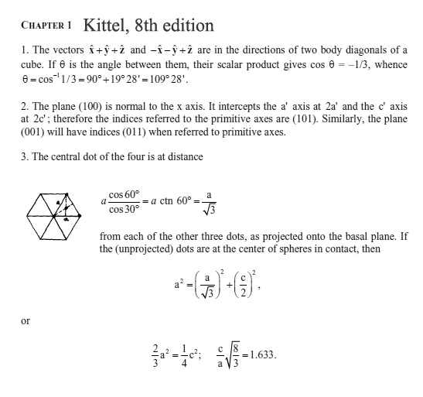

4. The book tells us that the packing fraction for the diamond structure is 0.34.
Show this using a clear picture/diagram and labeled, logical steps.
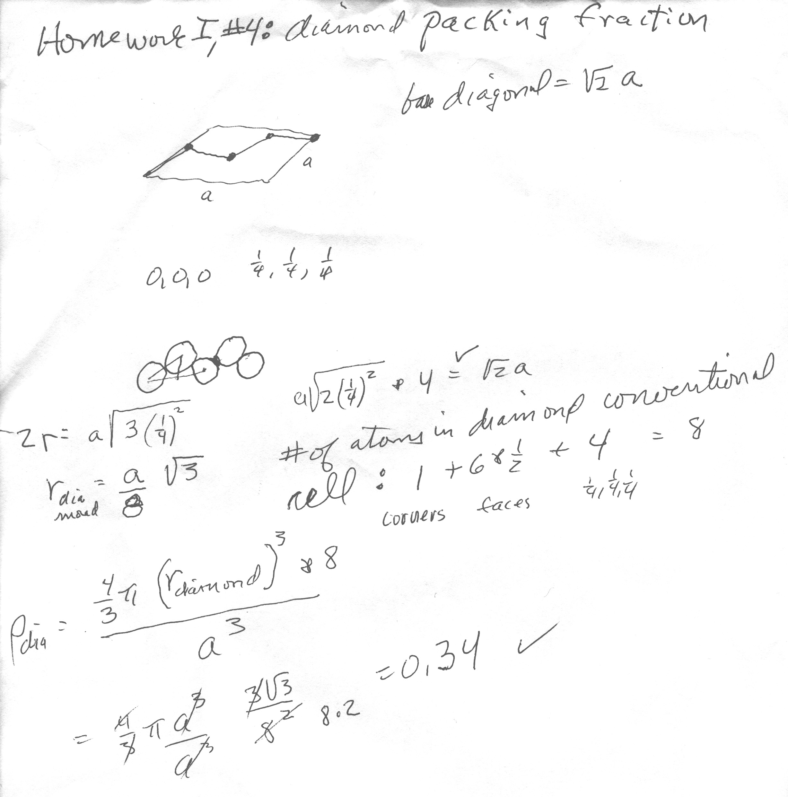

5. Consider a cubic lattice with primitive vectors a₁ , a₂ , a₃ . (where the notation here is an underlined symbol is a vector) Calculate the Miller indices of the plane with intercepts 4a₁ , a₂ , -3a₃ . What is the direction perpendicular to this plane?

Intercepts are 4,1,-3 as given. The reciprocals are ¼, 1, -1/3
The smallest set of 3 integers with the same ratio as the reciprocals is 3, 12, -4, which are therefore the Miller indices for the plane with the given intercepts.
Since the lattice was given as cubic, the direction perpendicular to this plane is [3,12,-4]

