Homework solutions Chap. 6: 1,2,5,10
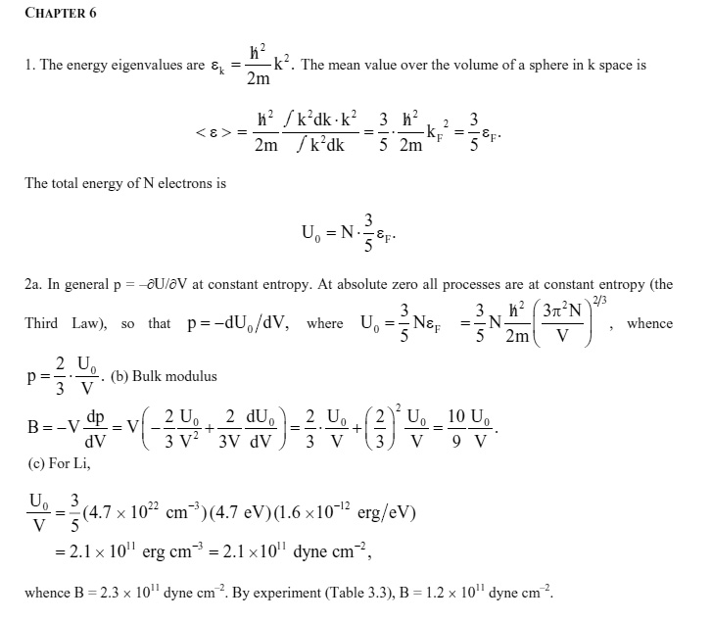
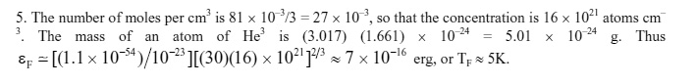

There are a few errors in these solutions – if you have questions, see me
