Test 1, PHY4905, Spring 2016
Chaps. 1-3, 5 February 8, 2016
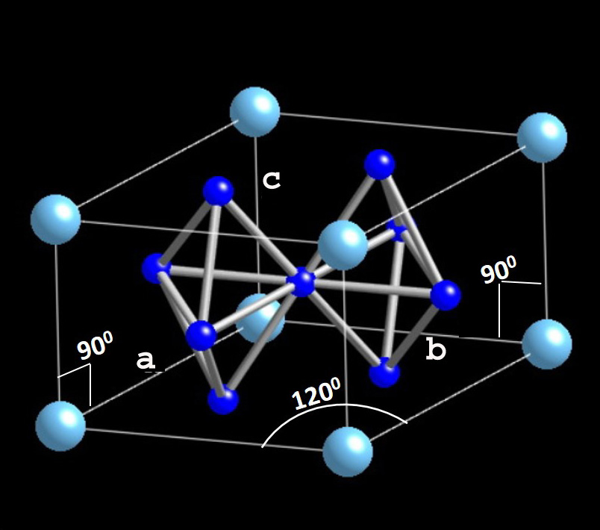
1. Consider the hexagonal compound CaCu₅, which has the Ca atoms (light blue) at the corners (shown is one third of a full hexagon) and four of the Cu atoms on the faces (note that the top and bottom faces (which are NOT square) have two Cu atoms each while the other four faces (which are square) only have one) with the fifth Cu atom in the body centered position. The a and b lattice parameters in the base are equal, and equal to 5.082 Å, while the c-axis = 4.078 Å. The atoms are described by the following positions (see picture of the conventional cell) (take the origin 0,0,0 at the back rear of the bottom plane):
Ca: one at 0,0,0
Cu (3 different symmetry sites): one atom at: ½, ½, ½; one atom at ½, 0, ½ (left side face) and one atom at 0, ½, ½ (back side face) and one atom at 2/3, 1/3, 0 and one atom at 1/3, 2/3, 0 (note that a and b are not orthogonal but rather have a 120 º angle between them)

a.) (2 pts) what is the physical mass density, units of g/cm³, of CaCu₅, if the molar mass of Ca is 40.078 g and of Cu 63.546 g?
in one unit cell, vol=a dot bxc=91.21 Å³ (since b and c are orthogonal, the magnitude of b x c is (bc) and the direction is perpendicular to the b-axis. Thus, a dot b x c is (abc) times cos 60º since a perpendicular to the b-axis makes a 30º angle with the a-axis. (you can also just use trig with the base as given in the picture.)
in this cell are 1 Ca atom (=1/8 * 8 for the cube corners) plus 5 Cu atoms. The masses are 1 *(40.078 g/mole)/6.022x10²³ atoms/mole and 5*63.546 gmole/6.022 10²³ atoms/mole = (357.808)x10⁻²³ g/6.022 * 91.21 10⁻²⁴ cm³=6.51 g/cm³

b.) (2 pts) Using f_{Ca} and f_{Cu} for the atomic form factors of Ca and Cu respectively, write down the structure factor, S_{G}, using the 6 atom positions given above for the basis,
S_{G} = Σ_{j} f_{j} exp(-i2π[ hx_{j} + ky_{j} + lz_{j} ]) where the sum is over j=1 to 6 for the basis atoms and the positions of the basis atoms are
r_{j} = x_{j} a₁ + y_{j} a₂ + z_{j} a₃ and the a_{i} are the conventional cell vectors. (Note again that a₁ and a₂ are not orthogonal.)
S_{G}=f_{Ca}(1) + f_{Cu}(exp(-πi(h + k + l)) + exp(-πi(h + l)) + exp(-πi(k + l)) + exp(-2πi(2/3h + 1/3k)) + exp(-2πi(1/3h + 2/3k)

c.) 4 pts What is the structure factor for the following (hkl) values:
(hkl) = (100), (001), (101), (110), (111)? (This is more than the three – 100, 101, and 111 - asked for on the test, just for you information) (please convert to numbers, rather than leaving it as, for example, an answer that contains exp(iπ) (which is -1) or exp(-i2π/3) which is -0.5 -i√3/2. So, if the answer should be 0, and you have the sum of a bunch of exponentials that would add to zero if you did the conversions, you don't get credit.)
plug these hkl into answer to b. and look for a pattern
100 gives f_{Ca}(1) + f_{Cu}(-1-1+1-1/2+i√3/2 -1/2 - i√3/2 ) = f_{Ca} -2f_{Cu}
001 gives f_{Ca}(1) + f_{Cu}(-1-1-1+1+1) = f_{Ca} - f_{Cu}
101 gives f_{Ca}(1) + f_{Cu}(+1 +1 -1 -1/2 + i√3/2 -1/2 - i√3/2) = f_{Ca}
110 gives f_{Ca}(1) + f_{Cu}(+1-1-1+1+1)= f_{Ca} + f_{Cu}
111 gives f_{Ca}(1) + f_{Cu}(-1 +1 +1 +1 +1) = f_{Ca} + f_{Cu}(3)
d.) 2 pts The above values are amplitudes, and the measured xray intensities for each hkl line are arrived at via S_{hkl}* x S_{hkl}, where S* is the complex conjugate of S. Assume that the atomic form factors are just simply the Z (number of electrons) values, so f_{Ca}=20 and f_{Cu}=29. What hkl gives the largest intensity? All the amplitudes are real. (100) gives -38, (101) gives 20, and (111) gives 107 for amplitudes. Squaring these . . . (111) is the largest, which in fact agrees with the xray pattern. In fact, (100) [(-38]² =1444] and (101) (20²=400) also have relative intensities that agree with what we calculate.
2. Consider the van der Waals (also known as Lennard Jones) potential, where dipole-dipole attractions lead to a –(σ/R)⁶ attraction term. We discussed in class how a +(σ/R)¹² repulsive potential term is added to represent hard core repulsion. We learned how, over the entire crystal, that the potential U was summed over all atoms j (not including atom i where the interaction was being considered as being on, and then the result is multiplied by N, the number of atoms in the crystal):
Eq. 1: U = 2Nε [ Σ_{j}’ (σ/p_{ij}R)¹² - Σ_{j}’ (σ/p_{ij}R)⁶ ] where p_{ij}R is the distance between reference atom i and any other atom j, expressed in terms of the nearest neighbor distance R. For computational purposes, one can assume various repulsive terms instead of the (1/R¹²) term. One such assumption is the so-called Lennard Jones 9-6 potential, where the potential energy of two atoms at separation R is:
U = A/R⁹ – B/R⁶, where A≡2εR₀⁹ and B≡3εR₀⁶, where R₀ is the equilibrium separation between two atoms.
a.) 1 pt In terms of A and B, calculate R₀
equilibrium is when the potential energy is at its minimum (or, equivalently, when the force= -dU/dR = 0.) -9A/R¹⁰ + 6B/R⁷ =0 => 6B=9A/R₀³ or R₀=(1.5A/B)^{1/3}
b.) 1 pt At the equilibrium separation R₀, calculate U in terms of ε.
U at R₀ = A/R₀⁹ – B/R₀⁶. Substitute the given for A and B: 2εR₀⁹/R₀⁹ - 3εR₀⁶/R₀⁶ = -ε
which is just the equilibrium separation energy ε₀.
c.) 1 point In fcc for the Lennard Jones 12-6 potential, the sum Σ_{j}’ (1/p_{ij})¹² = 12.13188 and Σ_{j}’ (1/p_{ij})⁶ = 14.45392 For the 9-6 potential, the second sum is the same but the first one is different. Qualitatively, in fcc, would you expect the sum Σ_{j}’ (1/p_{ij})⁹ to be larger, smaller, or the same as 12.13188? Explain your reasoning.
There are 12 nearest neighbors in fcc. When the sum Σ_{j}’ (1/p_{ij})¹² is calculated, p_{ij} for the nearest neighbors is just 1, and thus the nearest neighbors contribute already 12 to the sum of 12.13188. The next nearest neighbors in fcc, instead of being (√2/2)a distant (where a is the lattice cube edge length) is just ‘a’, which is √2 longer than the nearest neighbor distance. When you sum (1/√2)¹² over the number (6) of next nearest neighbors in fcc, you get 6*(1/64)=0.09375. And so on. If you add 6 times (1/√2)⁹, you already get 12 + 0.2652, so the sum of Σ_{j}’ (1/p_{ij})⁹ in fcc is larger.
d.) 2 points Using your answer from c.), would you expect the calculated equilibrium separation for a lattice of atoms (Eq. 1 above) arranged in the fcc structure to be larger, smaller, or the same using a Lennard Jones 9-6 potential instead of the usual 12-6 potential?
Just as we did when we had the 12-6 potential, take the first derivative of
Σ_{j}’ (σ/p_{ij}R)⁹ - Σ_{j}’ (σ/p_{ij}R)⁶ to get 9*(>12.2652) σ⁹/R₀¹⁰ – 6*14.45392 σ⁶/R₀⁷ = 0 and solve
9*(>12.2652) σ³/R₀³ – 6*14.45392 = 0 or R₀³/σ³ = 9*(>12.2652)/ 6*14.45392, so we see that the equilibrium separation is larger. In real calculations, when the sum of Σ_{j}’ (1/p_{ij})⁹ is done completely, the answer computationally is about 1.7% larger R₀, which is not bad considering that 12.2652 is already 1.1% larger than 12.13188.
3. Einstein Model of the Specific Heat at constant volume:
As given in Kittel, in 3 dimensions (where N is Avogadro’s number for the number of atoms in 1 mole, and k_{B}=1.38 10⁻²³ J/K and ω₀ is the Einstein frequency
C_{V}^{E} = 3 N k_{B} (ħω₀/(k_{B}T))² [exp(ħω₀/(k_{B}T)]/[exp(ħω₀/(k_{B}T)) – 1)]²
a.) What is the numerical value of C_{V}^{E}, in units of J/molK, at a temperature = ½ ħω₀/k_{B}
C_{V}^{E} =3R 4 exp2/[exp2 – 1]² =3 * 8.314 J/molK * 4 * 7.389/[6.389]² = 24.942 * 0.724 = 18.06 J/molK
b.) From the graph below and your result for part a, what would be the approximate Einstein temperature for Si?
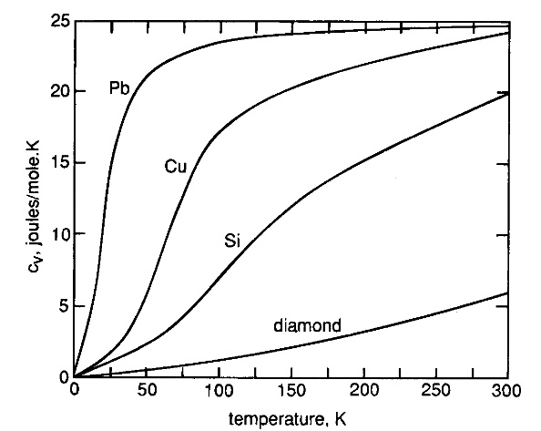

About 480 K
c.) What is the high temperature value of C_{V}^{E}? Show your calculation.
Call ħω₀/(k_{B}T) =x, so C_{V}^{E} = 24.942 (x)² [exp(x)]/[exp(x) – 1)]² ; as T->large, x->0; expand exp(x) = 1 + x, so have C_{V}^{E} (T->∞) = 24.942 (x)² * (1+x)/x² = 24.942 J/molK, or 3 R, which is just the Dulong Petit value.

