1. Consider the compound CaF₂, which has the Ca atoms face centered and the F atoms form a simple cube within the Ca fcc cube. It has atoms described by the following positions (see picture of the conventional cell):
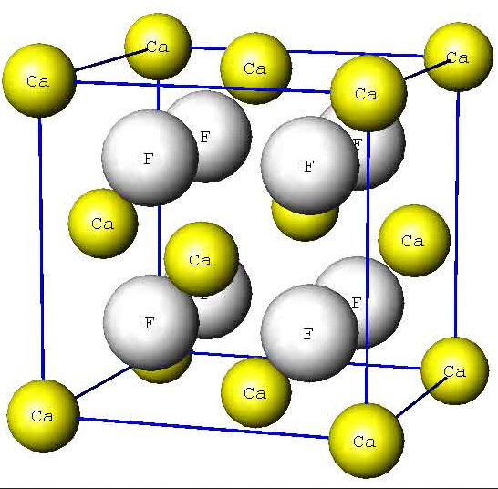
Ca: four atoms, one at 0,0,0; one at ½, ½, 0; one at ½, 0, ½; one at 0, ½, ½
F: eight atoms at: 1/4, 1/4, 1/4 ; 3/4, 1/4, 1/4 ; 1/4, 3/4, 1/4; 3/4, 3/4, 1/4;
1/4, 1/4, 3/4; 3/4, 1/4, 3/4; 1/4, 3/4, 3/4; 3/4, 3/4, 3/4
i. e. each F atom has four Ca atoms tetrahedrally associated with it. CaF₂ has a cube edge of 5.462 Å
Figure 1: conventional cell, large (white gray) spheres are the F, smaller (yellow) spheres are Ca.
a.) (2 pts) what is the physical mass density, units of g/cm³, of CaF₂, if the molar mass of Ca is 40.078 g and of F 18.998 g?
in one unit cell, vol=a³=162.95 Å³
in this cell are 4 Ca atoms (=1/8 * 8 for the cube corners and 6x1/2 for the 6 faces) plus 8 F atoms. The masses are 4 *(40.078 g/mole)/6.022x10²³ atoms/mole and 8*18.998 gmole/6.022 10²³ atoms/mole = (26.62+25.24)x10⁻²³ g/162.95 10⁻²⁴ cm³=3.18 g/cm³

b.) (2 pts) Using f_{Ca} and f_{F} for the atomic form factors of Ca and F respectively, write down the structure factor, S_{G}, using the 12 atom positions given above for the basis,
S_{G} = Σ_{j} f_{j} exp(-i2π[ hx_{j} + ky_{j} + lz_{j} ]) where the sum is over j=1 to 12 for the basis atoms and the positions of the basis atoms are
r_{j} = x_{j}a₁ + y_{j}a₂ + z_{j}a₃ and the a_{i} are the conventional cell vectors.
S_{G}=f_{Ca}(1 + exp(-iπ(h+k)) + exp(-iπ(h+l)) + exp(-iπ(k+l))) + f_{F}(exp(-πi(h + k + l)/2) + exp(-πi(3h + k + l)/2) + exp(-πi(h + 3k + l)/2) + exp(-πi(3h + 3k + l)/2) + exp(-πi(h + k + 3l)/2) + exp(-πi(3h + k + 3l)/2) + exp(-πi(h + 3k + 3l)/2) + exp(-πi(3h + 3k + 3l)/2))

c.) 4 pts What is the structure factor for the following (hkl) values:
(hkl) = (100), (001), (110), (103), (112), (200), (210) ? (please convert to numbers, rather than leaving it as, for example, an answer that contains exp(iπ) (which is -1) or exp(-i2π/3) which is -0.5 -i√3/2. So, if the answer should be 0, and you have the sum of a bunch of exponentials that would add to zero if you did the conversions, you don't get credit.)
plug these hkl into answer to b. and look for a pattern
100 gives f_{Ca}(1-1-1+1) + f_{F}(-i+i-i+i-i+i-i+i) = 0
001 gives f_{Ca}(1+1-1-1) + f_{F}(-i-i-i-i+i+i+i+i) = 0
110 gives f_{Ca}(1+1-1-1) + f_{F}(-1+1+1-1-1+1+1-1)=0
103 gives f_{Ca}(1-1+1-1) + f_{Si}(1-1+1-1-1+1-1+1)=0
112 gives f_{Ca}(1+1-1-1) + f_{F}(+1-1-1+1+1-1-1+1)=0
200 give f_{Ca}(1+1+1+1) + f_{F}(-1-1-1-1-1-1-1-1)=4f_{Ca} -8f_{F}, so this is finite when S*S is calculated, and of course f_{Ca} ≠ f_{F}
210 gives f_{Ca}(1-1+1-1) + f_{F}(i+i-i-i+i+i-i-i) = 0

d.) 2 pts For full credit, can you see a pattern? For which general rule of (hkl) is S_{G} finite or zero?
Clearly, 400, 600 etc. are finite.

