Test II, PHY4905, Chapters 6-10
Spring, 2016
3 significant figures unless otherwise stated on all answers please
Constants: N (Avogadro’s number)=6.022 10²³; ħ (Planck’s constant)=1.055 10⁻³⁴ J-s
1 J=0.6242 10¹⁹ eV; m(electron)=9.11 10⁻³¹ kg; k_{B}=0.86167 10⁻⁴ eV/K = 1.38044 10⁻²³ J/K

- An metallic element has a density of 3.51 g/cm³ and a molar volume of 39.1 cm³. The element is divalent, i. e. each atom of the element contributes two electrons to the Fermi sea.
a.(1 pt) What is the mass per mole, in g (4 sig figs)?
137.2
b. (2 pts) What is the density of electrons, N/V, per unit volume, in units of
electrons/cm³?
A mole of the material takes up 39.1 cm³, so N/V=2*6.022 10²³ /39.1 cm³ = 3.08 10²² e/cm³
c. (4 pts) Using the free electron model, calculate the specific heat gamma (γ) in
units of mJ/molK².
Kittel, eqn. 34, C_{el}=1/3 π²D(ε_{F})k_{B}²T where, eqn. 20, D(ε_{F})=[V/(2π²)](2m/ћ²)^{3/2}ε_{F}^{1/2} and eqn. 17, ε_{F}=(ћ²/2m)(3π²N/V)^{2/3}
so γ=1/3 π²k_{B}²[V/(2π²)](2m/ћ²)^{3/2}(ћ²/2m)^{1/2} (3π²N/V)^{1/3}
=1/6 k_{B}² V (2m/ћ²) (3π²N/V)^{1/3} =
1/6 (1.38 10⁻²³ J/K)² 39.1 cm³/mole (2x9.11 10⁻³¹ kg/1.055² 10⁻⁶⁸ J²s²)(3π²3.08 10²²e/cm³)^{1/3}
203.15 * (912)^{1/3} 10⁻⁴⁶ 10³⁷ 10⁷ J²/K² cm³/mole kg J⁻² s⁻² cm⁻¹ =
1970.1 10⁻² kgcm²/s²K² = 1.97 mJ/molK²

Many of you used instead Kittel eq. 36 γ=1/2 π² Nk_{B}²/ε_{F}, and then
ε_{F} = (ћ²/2m)(3π²N/V)^{2/3} eq. 17 (used in solution above). That would be fine. About 4 of you got ε_{F} right, and then plugged into eq. 36. *But*, although you used the correct N/V from part b.) where there are two electrons per atom and therefore N=2*Avogadro’s number, when you got to eq. 36 and plugged your correct ε_{F} in, you reverted to using N as Avogadro’s number. It’s still the number of electrons, which is 2*Avogadro’s #. So you were a factor of 2 too small. This mysterious mistake on the part of a number of you took a while to figure out. Just for fun, the correct γ is 2.7 mJ/molK², so the free electron model is not so bad.

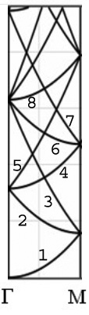
2.) In the homework, we did the empty lattice bands for simple cubic in the [111] direction of k-space. Here we do the empty lattice bands for simple cubic in the [110] direction, called the M direction. The graph at left is to scale.

a.) (2 pts) Write the general expression for the energy of the bands involving the k_{x}, k_{y}, and k_{z} as well as G_{x}, G_{y}, and G_{z}.
ε=(k_{x} + G_{x})² + (k_{y} + G_{y})² + (G_{z})²

b.) (2 pts) What is the energy, using ћ²/2m=1, for band 1 at the M point? (Express in terms of (π/a)²)
Band 1: G=000; k_{x}² and k_{y}² at the zone boundary are each (π/a)² so band 1 rises from ε=0 to 2(π/a)² at the zone boundary.

c.) (4 pts) Use the general expression from part a.) for the energy of band 8. Which values of G_{x}, G_{y}, and G_{z} are degenerate for this band (i. e. give the same energy)? What is the energy (Express in terms of (π/a)²) for band 8 at the Γ point, and at the M point, using ћ²/2m=1?
From looking at the graph, Band 5 starts at 4(π/a)² at the Γ point and Band 8 starts at 8(π/a)² and ends at the M point at 10(π/a)². So, need an even multiple of (π/a)² (specifically 8 and 10), so we could have G= -1, 1, 0 or G= 1, -1, 0 to give at zone center:
ε=(G_{x})² + (G_{y})² =(2π/a)² + (2π/a)² = 8(π/a)² and at the M point for -1,1,0:
ε=(k_{x} + G_{x})²+(k_{y}+G_{y})²=(π/a - 2π/a)²+(π/a + 2π/a)²=(1+9) (π/a)²
and for 1,-1,0 similarly (π/a + 2π/a)²+(π/a - 2π/a)² = 10 (π/a)²

3.) The electron carrier concentration at room temperature in intrinsic Ge is 7 10¹⁹/m³, and the electron mobility is 0.36 m²/V-s (both numbers out of Kittel). The hole mobility is 0.18 m²/V-s and, in intrinsic material, the hole carrier concentration is the same as for the electrons, 7 10¹⁹/m³.
a.) (2 pts) What is the electrical resistivity, in units of Ω-m?

ρ=1/(neμ_{e} + peμ_{h}) = 1/(7x10¹⁹ 1.6 10⁻¹⁹ 0.36 C/(V-s-m) + 7 10¹⁹ 1.6 10⁻¹⁹ 0.18 /Ω-m)
Since C/s = Amp and Amp/V = 1/Ω
ρ = 1/(4.03 /Ω-m + 2.016 /Ω-m) = (1/6.046 )Ω-m = 0.165 Ω-m

b.) (2 pts) Considering now just the electron charge carriers, if m_{electron} in Ge is 0.5 times the rest mass of the electron, what is τ, the collision time, in units of seconds?
μ_{e}=qτ_{e}/m_{e} so τ_{e} = [0.36 m²/Vs] * 0.5* 9.11 10⁻³¹ kg/1.602 10⁻¹⁹ C = 1.02 10⁻¹² s

4.) In 1911 the group of Kammerlingh Onnes discovered superconductivity in Hg, with an onset transition temperature, T_{c}, of 4.15 K. It was found that magnetic field suppressed T_{c}, with 0.030 T suppressing T_{c} to 2.2 K.
(2 pts) If the critical field as a function of temperature, H_{c}(T), of a superconductor behaves as
H_{c}(T) = H_{c}(0) [1-(T/T_{c})²]
what is the value (remember, 3 sig figs) of the critical field H_{c} at T=0, H_{c}(0), for mercury, in Tesla?
H_{c} (2.2 K)=0.030 T = H_{c}(0)[1-(2.2/4.15)²], so H_{c}(0) =0.0417 T

5.) The condensation energy of a superconductor is defined as the integral from 0 to T_{c} of the difference between the normal state, S_{n}, and superconducting state, S_{sc}, entropies:

U = ∫₀^{Tc} (S_{n} – S_{sc})dT

Since the phonon contribution to S_{n} and S_{sc} is the same, one can also just consider the electronic parts of the entropies, i. e. S_{n}^{elec} and S_{sc}^{elec}, in the integral.

One way to arrive at the entropy is via S(T) = ∫₀^{T} (C/T’)dT’, where C is the specific heat. Consider the figure below (Fig. 6 from Kittel, Chap. 10) showing the normal and superconducting state entropies of superconducting Al (the entropies are the electronic ones), T_{c}=1.18 K
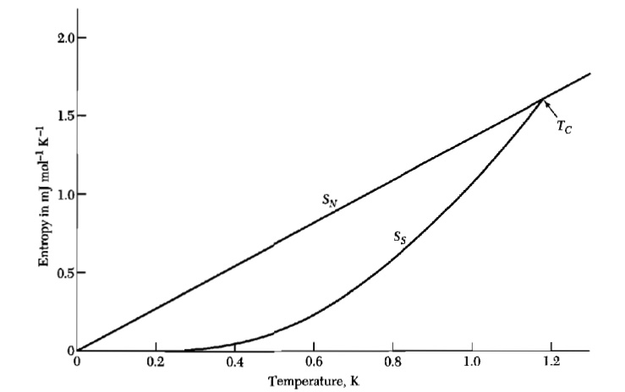

The entropy at T_{c} is 1.6 mJ/molK.
a.) (2 pts) Considering the normal state electronic entropy in the figure, what is the electronic specific heat γ of Al?
S(T) = ∫₀^{T} (C/T’)dT’, where C^{elec}/T = γ, so S_{n}^{elec} (T_{c}) = 1.6 mJ/molK = γT_{c}, so γ =1.6mJ/molK/1.18 K = 1.36 mJ/molK² (correct literature value)
b.) (2 pts) We have discussed in class that, before the BCS theory, the superconducting electronic specific heat, C, was approximated as const.*T³. Plug this into the integral for S_{sc}^{elec}(T_{c}), what is the const.?
1.6 mJ/molK = ∫₀^{Tc} (C/T’)dT’ = const.*T_{c}³/3 => const.= 3*(1.6 mJ/molK)/1.18³K³
=2.92 mJ/molK⁴
c.) (3 pts) What is the condensation energy of Al (keep 5 sig figs until the answer, in 3 sig figs)?
S_{sc}^{elec} = γT ; S_{n}^{elec} = 2.92 mJ/molK⁴ T³/3
U = ∫₀^{Tc} [1.36*T mJ/molK² – (2.92/3) mJ/molK⁴(T³)]dT = 1.36 *1.18²/2 –[2.92/3]*(1.18)⁴/4 in units of mJ/mol = 0.94683 – 0.47177 = 0.475 mJ/mol (vs literature value of 0.44)

