Abstract:

LHC and CMS will be online in 2007 and therefore muon cathode strip chambers need to be made and tested. These chambers must be very efficient at identifying track segments from traversing ionizing particles if any hope of finding exotic particles exists since these particles are only produced every trillion or so collisions. In this report I will give a brief overview of the local Level-1 Trigger for the end cap detectors for CMS and investigate the efficiency for different modes and chamber arrangements recorded during a six-week beam test at CERN.

LHC and CMS:

The Large Hadron Collider (LHC) will collide protons at an unprecedented 14 TeV every 25 ns. That’s seven times the energy of Fermilab’s Tevatron. With that energy all sorts of new physics is expected. The most probable particle to be found is the Higgs boson (if it isn’t found at the Tevatron first).
Anything with mass couples to the Higgs field; the more massive the particle, the stronger the coupling. The Higgs particle is very massive—more than 100 GeV—therefore, it is too massive for current accelerators to produce in any sizeable quantity. However, LHC should have no problem producing these particles.
The Higgs boson is not the most exotic particle that physicists hope to create at the LHC. One of the aesthetic problems with the Standard Model is that it requires special fine-tuning and doesn’t unify the four known forces. It does a very good job of explaining sub-atomic physics with just the electromagnetic, electro-weak, and strong forces but without gravity. Supersymmetry and superstring theory (which is string theory with supersymmetry) are two possible candidates to include gravity. They require supersymmetric particles, or sparticles.
These sparticles, such as sleptons and squarks, or photinos, etc. are identical to normal particles except that they are bosons instead of fermions (selectrons and electrons) or vice versa (photinos and photons). If they do exist, they must be very massive, because we haven’t observed any of these particles. So if they do exist, LHC should see them.
The Compact Muon Solenoid (CMS) is one of four detectors being built at LHC. CMS and ATLAS (A Toroidal LHC ApparatuS) are the two biggest, general-purpose detectors at LHC. CMS is the project that I am working on. Construction is scheduled to be finished in 2007.
Before a particle gets to any chamber in CMS it will have to make it through the detector’s absorbers that form the calorimeter system (energy measurements). These absorbers will stop just about every particle except muons. Hundreds of different particles will spray from the collision point, but they are mostly hadrons (particles composed of quarks). Since hadrons interact strongly with matter (by the strong force), they cannot penetrate very far into the absorbers.
Since quarks are ruled out, that leaves leptons (which only react electromagnetically and through the electroweak force). Neutrinos will make it though the core because they travel through everything relatively unimpeded; the only way to detect neutrinos at CMS is by their absence. That means that we can say that there was a neutral particle because what we detected didn’t add up to the total momentum. That only leaves three particles, electrons, muons, and taus. Electrons are very light particles so they don’t travel through matter very well, but muons, being 200 times as massive, can easily make it through the absorbers. Taus are even more massive than muons (more than ten times). However taus cannot make it through before decaying.
This rejection is beneficial since it tags the charged particle as a muon. This is why we need to assure maximum efficiency in detecting muons.

Trigger Architecture:

It is impossible to record data for every collision since the LHC will provide protons in bunches every 25 ns and approximately 17 collisions every bunch crossing (that’s approximately one billion collisions every second). This means that we have to have a way of taking out uninteresting collisions—this is the basis for the Trigger. The Trigger literally triggers the storage of event data for a certain collision. The Trigger must reduce the 1GHz of collisions down to 100Hz.
There are two Trigger levels: the Level-1 Trigger (L1T) and High Level Trigger (HLT). These triggers must reduce the 40MHz beam to 100Hz of data.

Cathode Strip Chamber (CSC) Design:
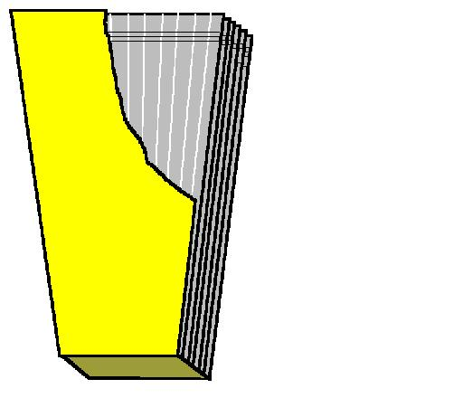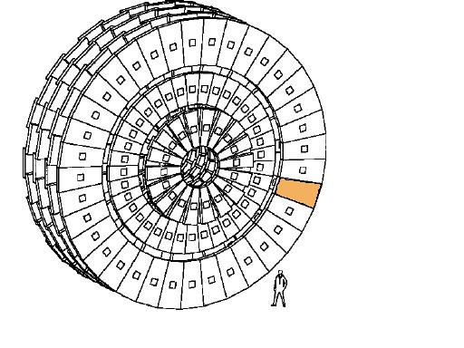
FIGURE 1: view of CSC FIGURE 2: Stations 1, 2,3, and 4 of the end cap CSC's
Fig. 1 shows what the CSC’s look like. There are many different CSC’s that go into different parts of the end cap section of CMS. There are four different stations or layers for the end cap section and are shown in Fig. 2. These stations assure nearly 100% coverage of all possible angles. Each station contains a number of chambers and is labeled thusly. ME (muon end cap) is the name given to these chambers such as ME 1/1. The first number is the station, and the second is a label for the ring it’s located on, going inside out.
The stations are broken up into 60° sectors for purposes of identifying muons in the L1T, except for ME1/x, which is broken up into two 30° sectors. Because of the location of each station, the design of the chambers for each station is slightly different.
Cathode strips run radially, while anode wires run approximately orthogonal to the strips. As a charged particle ionizes the gas electrons will be pulled to the wires and a signal can be seen on that wire. Since there are wires running orthogonal to each other we can determine where the particle “hit” the chamber by simply assigning Cartesian-like coordinates to the cathode strips and anode wires (although, actually the cathode strips represent the spherical coordinate ϕ, and anode wires represent the spherical coordinate η).
Parameter | ME1/1 | ME1/2 | ME1/2 | ME2/1 | ME3/1 | ME4/1 | ME234/2
wire spacing (mm) | 2.5 | 3.16 | 3.16 | 3.12 | 3.12 | 3.12 | 3.16
width of top (mm) | 487 | 819 | 933 | 1254 | 1254 | 1254 | 1270
width of bottom (mm) | 201 | 511 | 630 | 534 | 617 | 685 | 666
length (mm) | 1505 | 1635 | 1735 | 1900 | 1680 | 1500 | 3215
wires per plane | 600 | 528 | 560 | 620 | 550 | 492 | 1028
Δϕ for single strip (mrad) | 2.96 | 2.33 | 2.16 | 4.65 | 4.65 | 4.65 | 2.33
gap between strips (mm) | 0.35 | 0.5 | 0.5 | 0.5 | 0.5 | 0.5 | 0.5
Table I: Some specifications of the CSC’s for the end cap section of CMS.
The efficiency of a single CSC layer is not high enough, nor robust enough against backgrounds, for the L1T. This is why each chamber has six layers of identical panels or planes. A charged particle will leave a Local Charge Track (LCT) when traveling through any of these chambers. With the cathode strip and anode wires, these tracks can be correlated to make a 3-D picture of how the particle traversed the chamber.
Some specifications of each of the different chambers are given in Table I above.

Local CSC Level-1 Trigger:
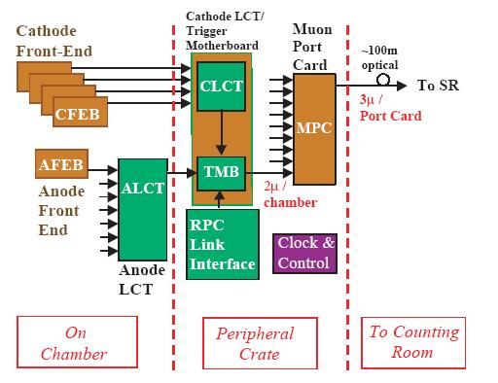
FIGURE 3: Block diagram for data flow in the CSC Local Trigger.
The local L1T consists of five parts: cathode front-end boards (CFEB), anode front-end boards (AFEB), anode LCT-finding boards (ALCT), cathode LCT-finding boards/trigger motherboard (CLCT/TMB), and muon port card (MPC) as shown in Fig. 3 above. The front-end boards amplify signals and send them to the proper LCT finding-board. Next these two signals are sent to the TMB which then sends a signal to the MPC which finally sends a signal to the sector receiver/sector processor (SR/SP).
The ALCT and CLCT boards work very similarly. The biggest difference is that ALCT’s are found for the wire groups and is located on the chamber, while CLCT’s are found for the strips and is located on the peripheral crate. They both compare LCT’s found to certain preset patterns. These patterns represent what an “interesting” LCT would look like and are assigned quality numbers. The ALCT and CLCT boards identify all LCT’s and send the best two (if there are more than two LCT’s, by highest assigned quality) to the TMB with information on those LCT’s. The ALCT board also differs from the CLCT board in that it is optimized to identify the bunch crossing (BX) or time.
The TMB takes the ALCT’s and CLCT’s and makes a 3-D correlated LCT (CorrLCT). This is done by time correlating an ALCT and CLCT (by BX). They can differ by at most two BX.
The TMB, which is located off of the chambers on the peripheral crate, sends up to two CorrLCT’s to the MPC (one for each sector). In stations two, three, and four there are nine chambers for each sector and therefore the MPC receives up to 18 CorrLCT’s. The pattern ID’s that are sent from the TMB serve as addresses to the Look-Up Table (LUT). The LUT contains pre-computed quality numbers (because it takes too long to compute them in real time). The MPC chooses the three best CorrLCT’s based on the LUT quality numbers and sends those three CorrLCT’s to the SR/SP. Station 1 still contains 9 chambers for each 30° sector so its MPC behaves the same as the other stations, except that its SR/SP receives signals from two MPC’s instead of just one.
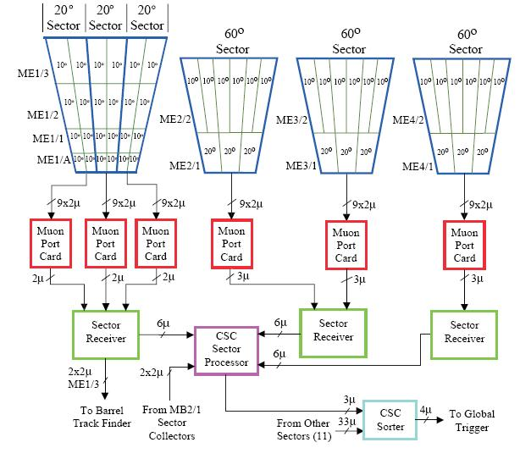
FIGURE 4: diagram showing the organization and data reduction of Level-1 Trigger. Note that for station 1, there are no ME1/A chambers and instead of being broken up into three 20°, it is broken up into two 30° sectors, but still all goes to one SR/SP.

Test Beam Set-up:

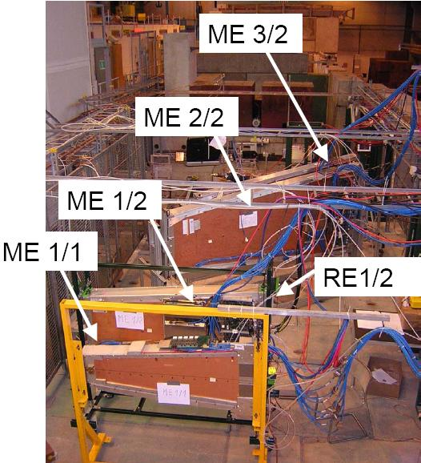
FIGURE 5: Chamber arrangement, with the second two chambers tilted by some angle
Fig. 5 shows a picture of the chambers and the order in which they were arranged for the test beam this May and June. The test beam was 100 GeV muons for the asynchronous period and both muons and pions were used during the synchronous period. Asynchronous means that the beam was not pulsed at the LHC frequency of 40MHz, so it was asynchronous with LHC where as during the synchronous period the beam was pulsed at the LHC frequency of 40MHz. The asynchronous period ran for three weeks from May 17 through June 8 and the synchronous period ran for one week from June 14 through June 21. Table II shows the chamber labeling for both asynchronous and synchronous periods as they appear in the plots located in Appendix A and B.

 | Asynchronous | Synchronous
ME1/1 | 10 | 2
ME1/2 | 1 | 8
ME2/2 | 3 | 3
ME3/2 | 8 | 9
Table II: Labeling for chambers in the plots in Appendix A.
The first two chambers (in the beam line) are two of the smaller chambers from station 1. The second two chambers are from the second and third stations, respectively.
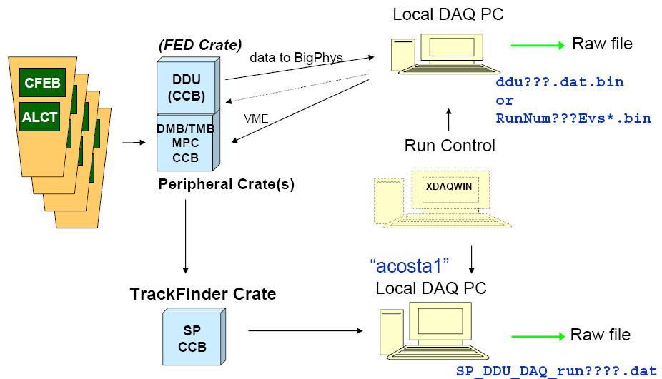
FIGURE 6: DAQ setup and flow for test beam
Fig. 6 shows the data acquisition setup for the test beam analysis.
The SR/SP or Track Finder receives data from MPC via an optical link. The Track Finder records data in a seven BX range (the data that I am analyzing) when it receives a signal from the scintillators located in front and behind the chambers as illustrated in Fig 7.
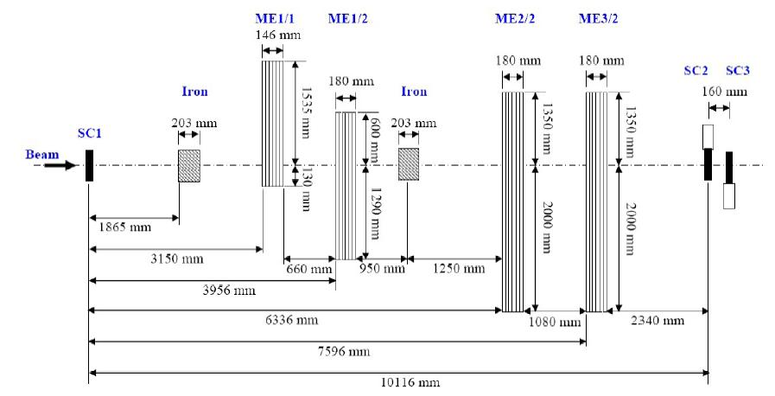
FIGURE 7: Shows the test beam setup, with the scintillators (SC1, SC2, SC3) in front and behind the chambers.
During the test beam several conditions were changed and tested. New ALCT firmware was made to lower ghost rates, and so this was tested. Also, the trigger modes were changed on the ALCT finding-boards to accept different types of patterns. The different trigger modes are described in Table III on page 16 of this document. Along with trigger modes, different collision patterns were used inside these trigger modes (Default, Miss4, and Andrey). These collisions patterns can be found in Fig. 9 in the results section on page 18 of this document. Chamber angles were varied to simulate the different angles that muons will be hitting the chambers during the actual experiment. The number of layers in a pattern required for a chamber to report an LCT was varied from four to six. Another variable was that an iron block was placed in front of the beam for some runs to simulate the iron absorber in the center of the CMS detector. Because the CLCT takes longer than the ALCT to report an LCT the ALCT must wait for the CLCT and this time it waits was varied, which is noted as ALCT delay.
Results:

There are two types of efficiencies: observed and corrected. The observed efficiency is simply the number of LCT’s found divided by the total number of events (for that chamber). The corrected efficiency takes into account di-muon events (which are instances where truly two different muons come through the chamber). Corrected efficiencies are calculated using laws of probability as described below.
T: total number of events
N₁: number of actual single muon events
N₂: number of actual di-muon events
n₁: number of observed single muon events
n₂: number of observed di-muon events
L: number of total events recorded
ε: Efficiency or probability of recording an LCT given there was one muon
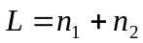 (1)
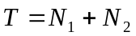 (2)
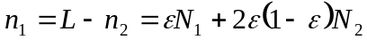 (3)
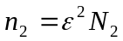 (4)
Combining Eqs. (2), (3), and (4):
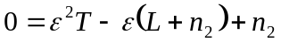 (5)

Using the quadratic equation:
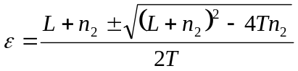 (6)
We take the higher efficiency because the observed efficiency should be close to the corrected efficiency assuming there are very few di-muons, which there always was. We see the low di-muon rate in Fig. 8 below, which is indicative of all di-muons rates. The corrected efficiency is given by Eq. 7:
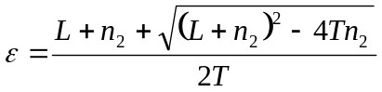 (7)
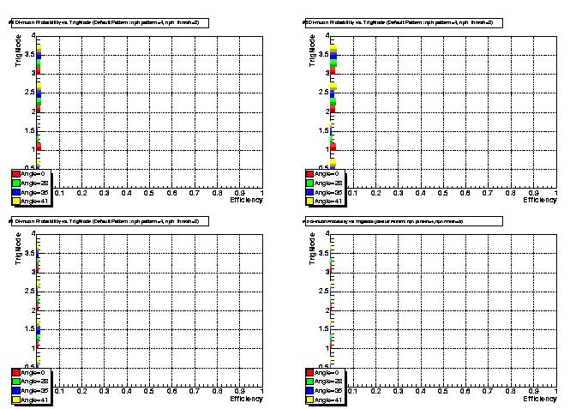
FIG. 8: di-muon probability for different trigger modes and angles
This is the efficiency that is plotted in the figures, located in Appendix A and B.
There are also three more different efficiencies: untagged, tagged by chamber, and tagged by chamber and bunch crossing (BX). Untagged means that every event gets counted for every chamber, tagged by chamber means that an event is only counted (in the total number of events) if at least one other chamber recorded an event, and tagged by chamber and BX means an event is only counted if it is recorded in at least one other chamber on the center BX. The center BX is the BX where most of the events lie. I used the efficiency calculated from tagged by chamber and BX for my plots.
Along with di-muon rates there is also a ghost muon probability. A ghost muon occurs when the TMB returns two LCT’s but they both lie on the same strip or wire group. The wire group requirement is less restrictive—if the difference in wire groups is one or less then it is a ghost. Because of this definition, ghost probabilities vary between different trigger modes.
All plots are located in Appendix A and B and I will refer to them by page number and Appendix label (i.e. 1A for page 1 of Appendix A).
Page 1A shows plots of total efficiencies for the Default pattern varying trigger mode and the tilt angle (for asynchronous period). Looking at just trigger mode two and an angle of zero degrees we see that the efficiency is very high for all chambers. The efficiencies (for same conditions) during the synchronous period can be found on page 1B and are high except for ME3/2, which dies out when we require an ALCT. The ghost probabilities are also very low for this setup. A new electronic transition card was added to the ALCT path and the zero efficiency for ME3/2 indicates a problem with the electronics or firmware.

The next sections discuss the different variation on the test beam and only data from the asynchronous period is included (Appendix A).

Firmware:
New ALCT firmware was introduced to lower the ghost probability, but the plots on page 4A show that neither the total efficiencies nor the ghost probabilities changed significantly.

Trigger Modes:
Trigger Mode 0: Acc. Pattern or Coll. Pattern
Trigger Mode 1: Acc. Pattern Only
Trigger Mode 2: Coll. Pattern Only
Trigger Mode 3: Acc. Pattern or Coll. Pattern (Acc. Pattern vetoes Coll. Pattern)
Table III: values for the different trigger modes.
The plots on page 1A show the angular dependence of efficiencies and the different trigger modes. Trigger mode 1 should be low at large angles because it only accepts straight patterns. The other three trigger modes all accept collision patterns and so should remain constant at all angles. When the tilt angle was 35° the efficiency was low for ME1/2 and ME3/2, which should not be, especially in ME1/2 because the angle was zero for all four runs. The next page shows the ghost probabilities for the same runs. Trigger mode 0 will be high for most runs because it is accepting the accelerator pattern or collision pattern with no cancellation. Therefore, as the angle increases and fewer accelerator patterns are seen, the ghost probability dies off. However, at 28° we see a jump for trigger mode 3. This should still be low, given, that ghost probabilities were low for accelerator only and collision only patterns because recall that if it sees both an accelerator and collision pattern, the accelerator pattern vetoes the collision pattern, so we shouldn’t see the high ghost rates that we see in trigger mode 0.

Page 7A shows the efficiencies when an iron block was placed in the beam line. The plots show that the efficiencies did not change significantly with the iron. This is a good result because there will be iron in the path that the muons take before they get to the chambers. These results show that there isn’t significant scattering, which would cause the efficiency to drop dramatically in trigger mode 1. The ghost rates only significantly increased for ME1/2 (which was at normal incidence both runs) for trigger mode 0. This result could be due to the fact that trigger mode 0 is accepting both collision and accelerator patterns, which means that it has one of each (which would keep all other trigger modes low). The scattering is not as significant for the ME2/2 and ME3/2 because they were tilted at 28° so accelerator patterns were already low, but at normal incidence the straight track could get tilted enough to be called a collision pattern as well.

Number of Layers Required:
There are six layers in the CSC—the default is that if a track matches a pattern for four of the six layers then it is an LCT. However, more than just 4 layers can be required. Page 10A shows plots at 0° for different numbers of layers. The result for the default pattern is that more layers significantly drop the efficiency. Going from four to five only drops the efficiency a few percentage points, but going from four to six drops the efficiency by almost 15%. More layers should lower the ghost rate because it requires the fit to the specific pattern to be very tight. However, for ME2/2 the ghost rate seems to increase for trigger mode 0.
Page 13A shows the same plots but now at 28°. The results are similar to the above. The ghost rates drop significantly at 28° with increasing layers required. However, the layers were kept the same for ME1/2 and yet the efficiency shows a dramatic change in trigger mode 0, so that run might be bad.

Patterns:
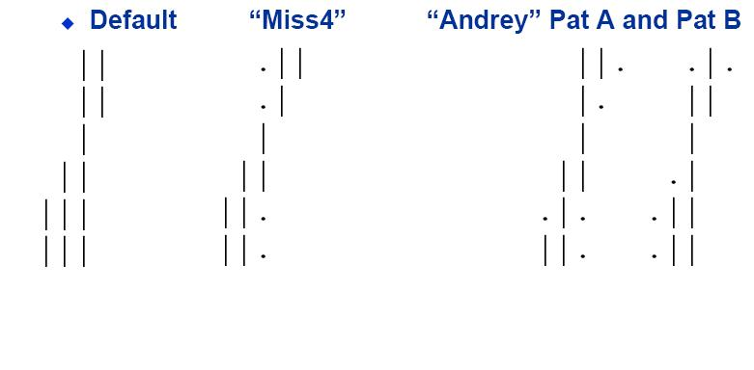
FIGURE 9: Shows the different collision patterns accepted by the ALCT finding-boards for the different types of patters.
There are three different sets of collision patterns, the Default, Miss4, and Andrey pattern and are shown in Fig. 9. Page 16A shows plots for the different patterns at 35 degrees. Overall the different patterns are approximately the same, except for trigger mode 2 on ME3/2. The Miss4 pattern is very low for ME1/2, which is not too surprising since that chamber was at normal incidence and recall that trigger mode 2 is for collision patterns only. The ghost rates are fairly normal. They are low for trigger mode 0 because the TMB didn’t return very many collisions patterns and therefore is about the same as trigger mode 1.

Page 19A shows the effect of different layers required. The more layers required dramatically drops off the efficiency, much more so than in the default pattern. It drops off 20% and then another 50% for layers required equaling five and six respectively, for both chambers and all trigger modes. The ghost rates are low but the cost is lower efficiencies.

Page 22A shows the same plot as above but with the tilt angle set to –30°. The results are the same as above, but even lower efficiencies are reached.

Page 25A shows plots for the Andrey Pattern while varying layers required. With the Andrey pattern the layers required does not affect the efficiency nearly as badly. Going from four to five is at most (other than trigger mode 1) a couple of percentage points difference; from four to six, the difference is approximately 5%. As usual, the larger layers required significantly lowers the ghost rates, but in the case of Andrey we did not lose efficiency.
Conclusions:

Based on the data collected, the Miss4 pattern seems to perform the best when the number of layers required is four. This gives high efficiency for collision patterns at an angle and low efficiencies for collision patterns at normal incidence. Miss4 also give low ghost rates for all trigger modes. These two facts are indicative of the fact that Miss4 does the best at distinguishing accelerator muons from collision muons.
Acknowledgements:

The author would like to thank Dr. Darin Acosta for overseeing this project. I would also like to thank Dr. Kevin Ingersent and Dr. Alan Dorsey from the University of Florida in Gainesville for overseeing the REU this summer.
Funding for this project was provided by a grant from the National Science Foundation.

