Paul Avery

Peter Hirschfeld

PHY3101

Oct. 4, 2018

Version 1

Quantum Mechanics: Identical Particles

**Table of contents**

1 Pauli Exclusion Principle, Fermions and Bosons 1

2 Schrödinger Equation for Multiple Non-Interacting Particles 2

2.1 Example: Two Particles in an Infinite Box 2

3 Identical Particles 2

3.1 Example: Comparison of 2-particle wavefunctions for the infinite box 3

References 6

# Pauli Exclusion Principle, Fermions and Bosons

We learned previously from Pauli’s *exclusion principle* that no two electrons can occupy the same quantum state. Thus as electrons are added to atoms they fill different spatial or spin quantum states at increasingly higher energies, forming atomic subshells and shells. The exclusion principle applies to all particles with half-integral spin (known as *fermions*). So spin ½ protons and neutrons are also subject to separate exclusion principles which form the basis of the nuclear shell model.

Particles like photons and mesons, which have integral spin, are known as *bosons*. Unlike Fermions, bosons have a tendency to cluster closer to one another, a characteristic that we will explore below and later when we take up statistical physics.

Figure 1 shows a list of particles and force carriers and their status as fermions or bosons. Leptons and quarks, the fundamental constituents of all matter, are spin ½ fermions. Force carriers are spin 1 bosons (photon, *W*, *Z*, gluon) or even spin 2 (graviton). Note that baryons such as the proton and neutron (3 quarks) and mesons (2 quarks) are composite particles.

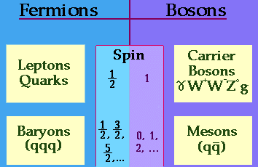

Figure 1: Figure showing particles which are fermions and bosons.[1]

# Schrödinger Equation for Multiple Non-Interacting Particles

The Schrödinger equation for multiple particles that are non-interacting is a simple generalization of our equation for a single particle. We assume that each particle moves in a common, time-independent potential *U*(**x**) with no mutual interactions.



We solve this equation by again invoking separation of variables:



The solution is straightforward: each particle wavefunction satisfies the SE equation for that particle and  is the total energy of the system. So far, so good.

## Example: Two Particles in an Infinite Box

Let’s assume we have two particles 1 and 2 of the same mass in an infinite potential box. The combined wavefunctions and energies are



The ground state has *n*1 = *n*2 = 1 and *E*11 = 2*E*0. Note that the first excited state has two independent wavefunctions (*ψ*12, *ψ*21) with the same energy 5*E*0 (i.e., the energy degeneracy is 2):



# Identical Particles

As we have just seen, handling multiple non-interacting particles in a common potential is straightforward when the particles have labels attached to them, i.e., they can be distinguished from one another. But what happens when the particles are identical and truly *indistinguishable*? If we do a measurement one might think we can find the probability of particle 1 being at *x*1 simultaneously when particle 2 is at position *x*2, but how do we know which is which when the particles are identical and have no labels?

This indistinguishability problem is fundamental to QM. If we want the probabilities to be unaffected by this indistinguishability, we can alter the product wavefunctions as follows.

First, let  represent the *full* wavefunction of the first particle, where all quantum labels except coordinates are combined into the single symbol *α*. Similarly, let  represent the full wavefunction of the second particle, where all its labels except coordinates are combined into the symbol *β*. Then we form the combinations by adding or subtracting wavefunctions with *all labels* switched



The “S” (symmetric) and “A” (antisymmetric) subscripts describe which combination is taken. (The constant *C* is chosen to maintain the unit normalization of *ψS* and *ψA*.)

These new wavefunctions satisfy



So taking the square of either wavefunction leaves the probability density unchanged.

But which combination should be taken? Relativistic QM relates tells us that combination depends on the spin of the particle through the *spin-statistics theorem*:[2]

*ψS*: Bosons (spin 0, 1, 2, …)

*ψA*: Fermions (spin 1/2, 3/2,. 5/2, …)

We can now see that the exclusion principle for fermions is merely a statement that if *α* = *β* (fermions in the same quantum state), then .

## Example: Comparison of 2-particle wavefunctions for the infinite box

The symmetric and antisymmetric combinations for indistinguishable particles behave quite differently from one another and from the distinguishability case. Let’s look at the probability density for two particles in an infinite potential box with quantum numbers *n*1 = 4, *n*2 = 3 and total energy . The three 2-particle wavefunctions are



(You can check that the normalization constants give total probability 1 for each case.) When the particles are distinguishable, the probability density graph  in Figure 2 shows that the *x*1 and *x*2 components are *independent* of one another, as expected.

The situation is quite different when the particles are indistinguishable. Figure 3 shows the same particles in a symmetric and antisymmetric combination where the probability density has strong correlations in the (*x*1,*x*2) coordinates. For the symmetric wavefunction the probability density peaks occur *close to* the line *x*1 = *x*2 (|*x*1 – *x*2| small) while for the antisymmetric wavefunction the probability density peaks occur *far from* the line *x*1 = *x*2 (|*x*1 – *x*2| large). Both of these behaviors make sense when we consider the symmetric and antisymmetric combinations near *x*1 = *x*2.

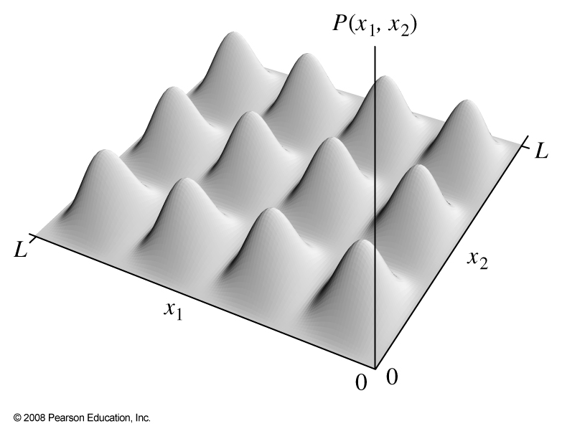

Figure 2: Probability density for two particles in an infinite box, *n*1 = 4, *n*2 = 3 where the two particles are distinguishable. The combined wavefunction is merely a product of the *x*1 and *x*2 wavefunctions.

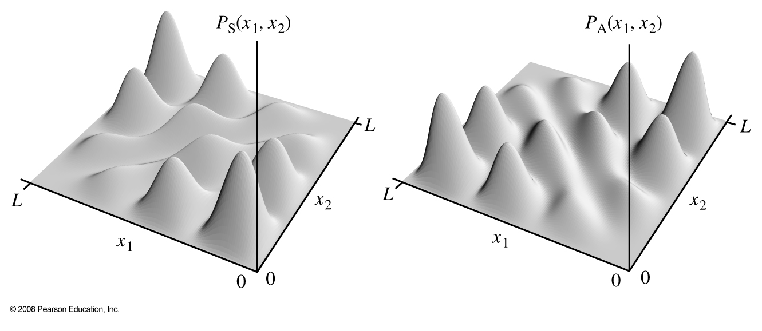

Figure 3: Probability density for two particles in an infinite box, *n*1 = 4, *n*2 = 3 where the two particles are indistinguishable. Shown are the symmetric (left) and antisymmetric wavefunctions (right). The red line is *x*1 = *x*2.

We can quantify this behavior by calculating the expectation value of  for the distinguishable, symmetric and antisymmetric cases (for *n*1 = 4, *n*2 = 3). The results are shown in the table below (using Sage)

|  |  |
| --- | --- |
| **Type** | (*n*1,*n*2) = (4,3) |
| Distinguishable | 0.158 *L* |
| Symmetric | 0.079 *L* |
| Antisymmetric | 0.237 *L* |

The two particles are thus on average *significantly closer together* in the symmetric wavefunction than in the antisymmetric wavefunction. The effect is dramatically illustrated in Figure 4, which shows the probability density distribution of  for (*n*1,*n*2) = (1,2) for the three combinations.[3]

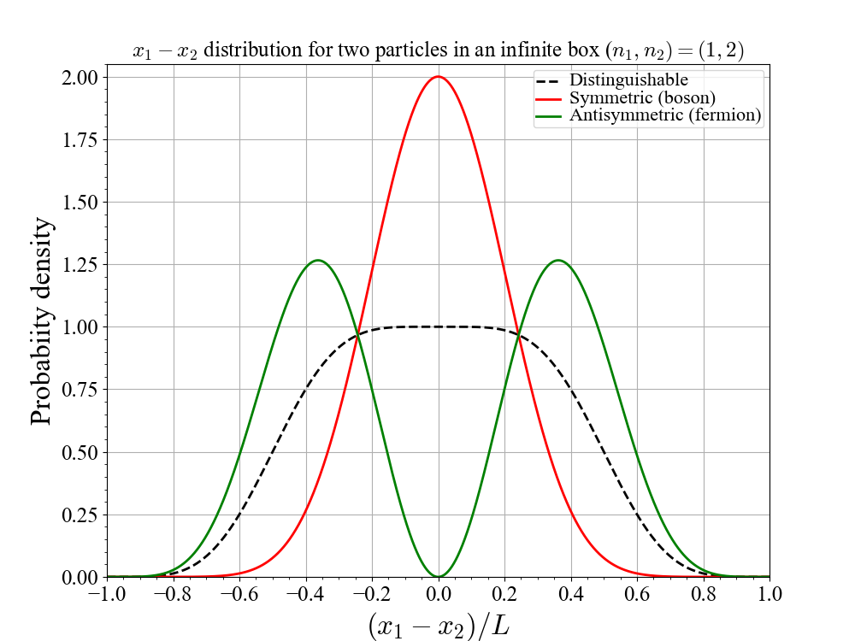

Figure 4: Distribution of the 2 particle separation in an infinite potential box

# References

1. Figure from <http://physics.bu.edu/ID500/fermion_boson_chart.html>
2. See <https://en.wikipedia.org/wiki/Spin%E2%80%93statistics_theorem>
3. I used (*n*1,*n*2) = (1,2) to make the distributions less complicated than for (4,3)