Caltech 40 metre Interferometer

Detector Characterisation

SPECTRAL PROPERTIES OF THE DATA

Department of Physics
The Australian National University (ANU)

Sub-group of ACIGA

Susan Scott Philip Charlton
David McClelland Benjamin Evans
Bernard Whiting John Sandeman

Data analysis sub-group came into existence six months ago

Preliminaries

- Installed and ran GRASP on several different SGI operating systems
- Read all available 40 metre data into ANU structured Mass Data Store
- Provision of interfaces between Matlab, FRAME and GRASP codes

Problem of Out of Lock Data

Our analysis requires the use of "good data"
i.e. data taken when the instrument is in lock

Use lock channel IFO_Lock?
Yes, but it's too coarse for our purposes

PROBLEM : the interferometer is not actually in lock for all sections of the lock channel showing "in lock data"

Manual fix : eliminate bad data by inspection

How could this process be carried out automatically?

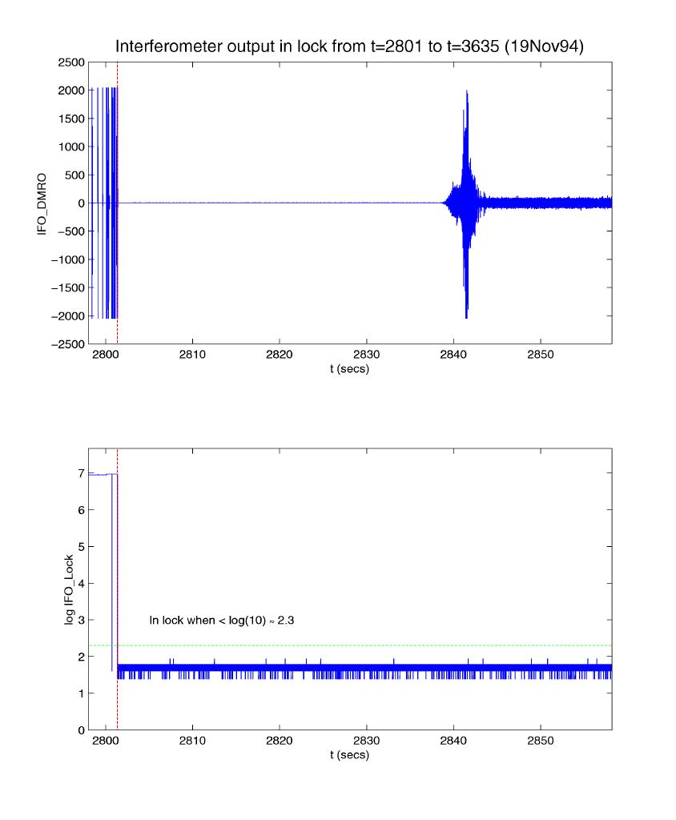

Automatic Procedure

Step 1 : Only consider data which the lock channel indicates is
"in lock"

Step 2 : Segment this "in lock" data into blocks of equal length
e.g. 1,000 data points

Step 3 : Compute the mean signal μ_{i} for each block and the
associated standard deviation σ_{i} for each block

Step 4 : Histogram the standard deviations σ_{i} for all the blocks

Step 5 : Using the histogram, select suitable (non-zero) minimum
and maximum standard deviations

Step 6 : Blocks with standard deviation lying between the

minimum and maximum are marked as good

Step 7 : The remaining blocks are marked as bad and discarded

Objective: to deliver code for this procedure to LIGO by June 2000

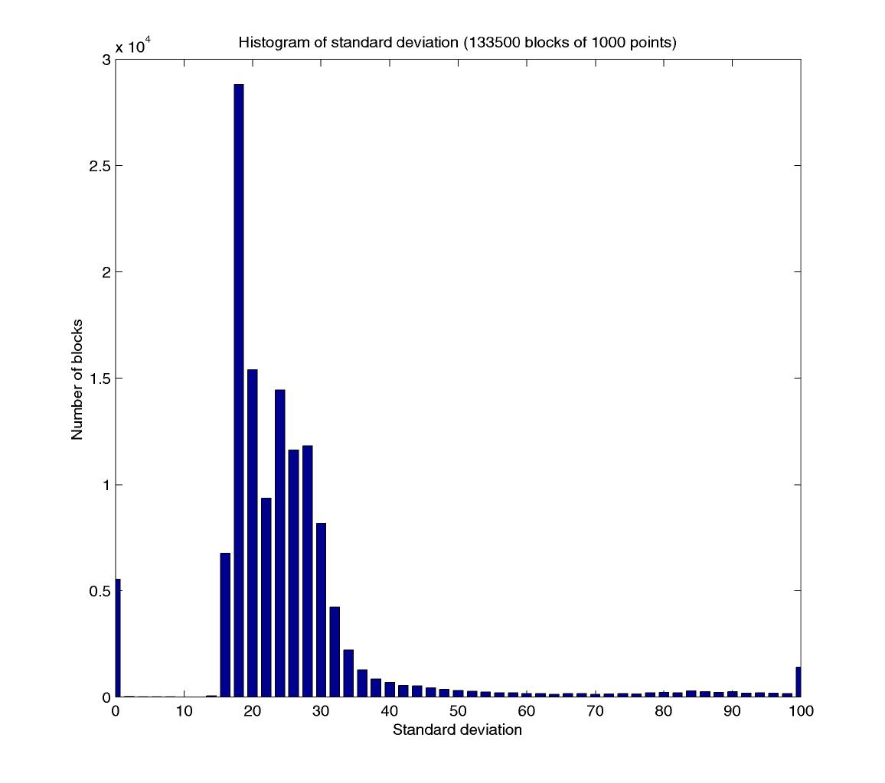

Frequency Histograms

- Use good blocks of 1,000 data points
- Pad the blocks out to 8,192 = 2¹³ points by adding zeros
- Consider the first 550 blocks of data
- Perform a Fast Fourier Transform (FFT) on each block
- Compile the FFT data into a array
- For each frequency:
- histogram the real part of the FFT (50 bins)
calculate the mean and standard deviation of the sample
- histogram the imaginary part of the FFT (50 bins)
calculate the mean and standard deviation of the sample
- Execute the same procedure for the next 550 blocks of data
- Combine with the first 550 block to compile histograms:
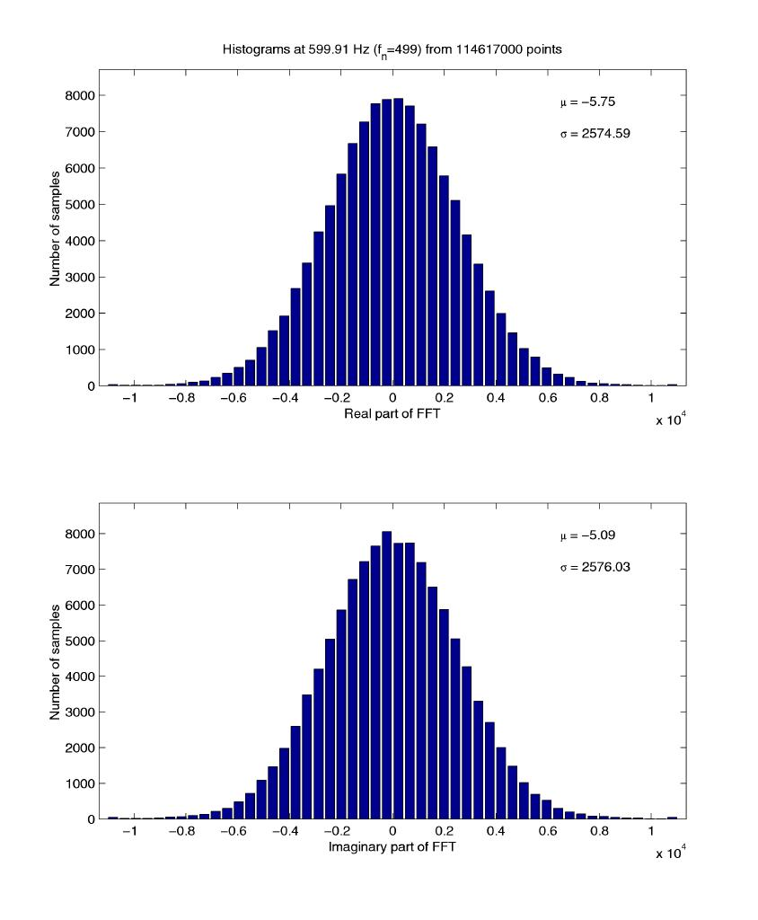

Likelihood Ratio as a Measure of Gaussianity

- Our samples of the real and imaginary components of the FFT for a given frequency are binned
- We can therefore assume that they are distributed multinomially, with probability p_{i} of a point falling into bin i

The likelihood function L for a multinomial distribution is given by
k is the number of bins
n_{i} is the number of points in bin i
is the total number of points

A likelihood ratio l is obtained by taking the ratio of L to the maximum value attainable by L as the n_{i}’s vary
N.B. subject to the constraint
This gives a value

Example

For 2M tosses of an unbiased coin, the likelihood of n heads is

The maximum likelihood is attained when n = M. Hence

The likelihood ratio is used to measure the Gaussianity of binned data
- Take the probabilities p_{i} from a normal distribution with mean μ and standard deviation σ :
x_{i} is the centre of the i th bin
Δx is the bin width
μ and σ are obtained from the frequency data

L attains its maximum at
Thus l is given by
In practice it is simpler to calculate log l

- Values of l close to 1 indicate a good fit to Gaussian
- For large N, l is extremely sharply peaked
- A more useful measure of Gaussianity is given by l^{1/N}
the N th root of l

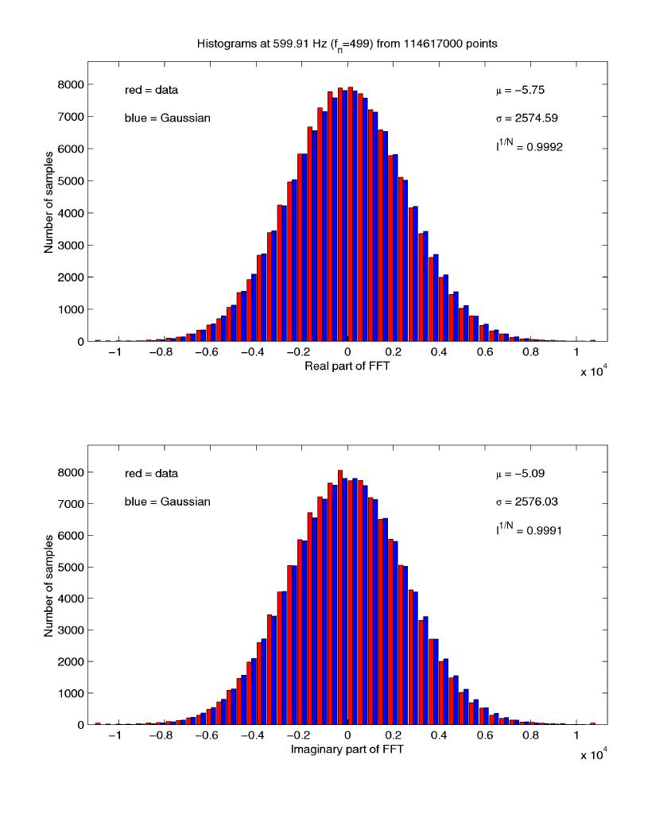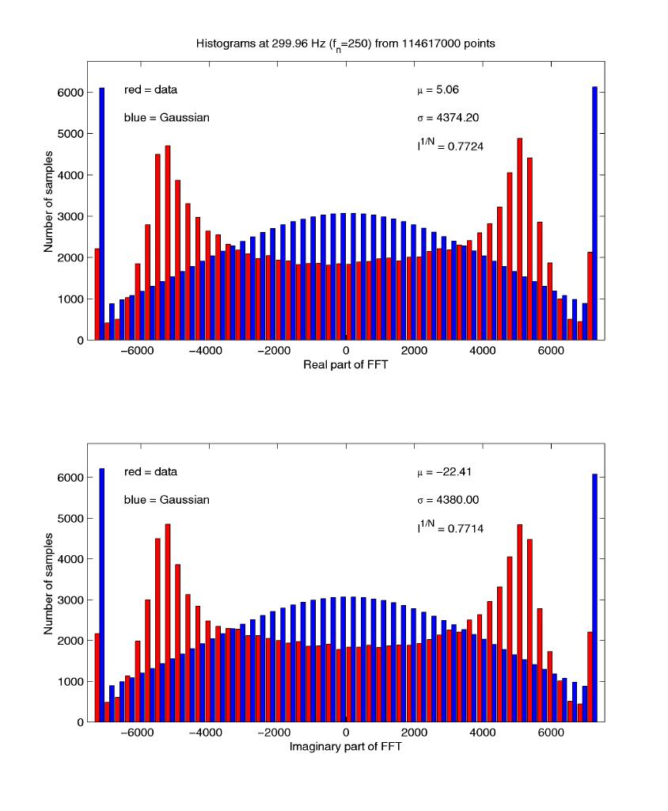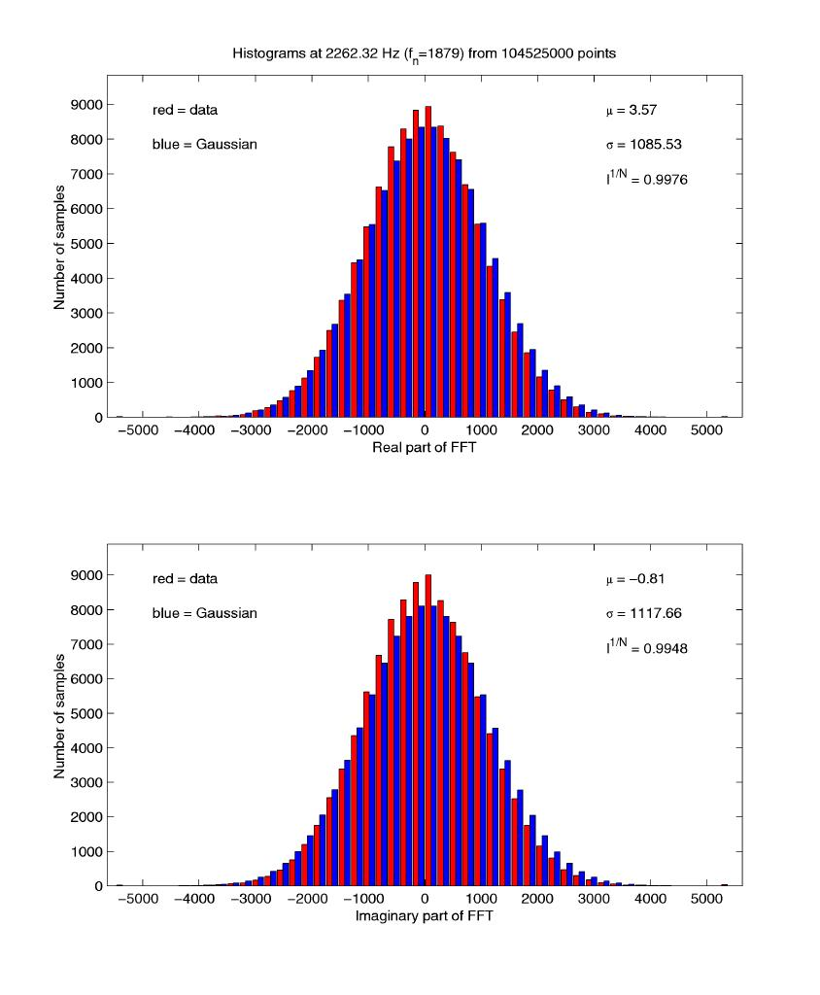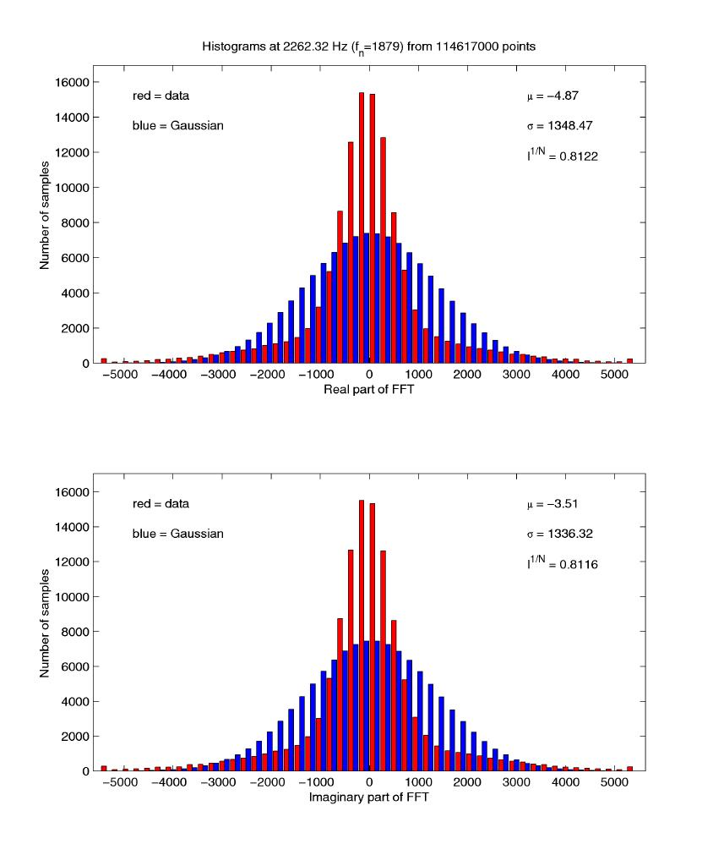
Work in Progress

- Speed tests on the SGI PowerChallenge

- Further measures of normality
e.g. skew, kurtosis, χ²-statistic

- Apply line removal techniques to 40 metre data

- Use the statistical analysis techniques outlined to measure the effects of different line removal techniques
(40 metre, Glasgow)

