BLI Integration.
Abli.zip
End point trap rule.docx Equation 9 is
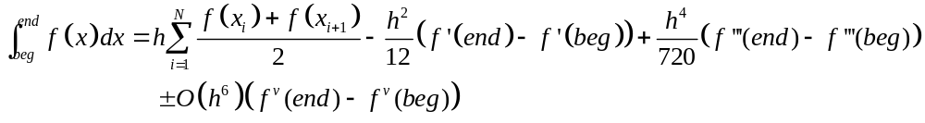
Approximate the fifth derivative by
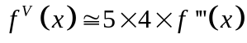
And assume that the coefficient of 1/720 remains the same.

Then the integral to x_{j} can be written as
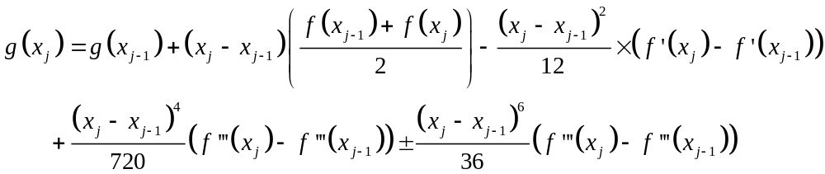
This leads to
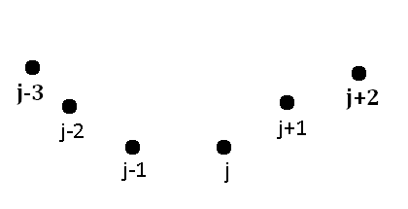
Figure 1 Intermediate values found by BLI
Derivatives at J-1 aredetermined by the curve through J-3to J+1. Derivatives at J are determined by the curve through J-2 to J+2.
The four values of f(x_{j}) most relevant for the integral from x_{j-1} to x_{j} are shown in figure 1. A Lagrange polynomial through the appropriate five points gives third derivatives at x_{j-1} and x_{j}. ..\Derivatives\Lagrange.docx
The goal is to spread N points from x₀ to x_{N} such that the error term in the integral is minimal.
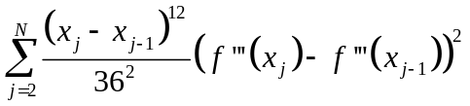
This is accomplished by finding values of for each interval,then adding new points in the middle of the intervals with the largest values of
..\interpolation\Bli.doc →Ibli.for

Richardson’s Extrapolation
Form three integral estimates using every point, every second point, and every third point out of the xi and fi vectors returned by BLI. Ignore the possibility of using the 1/N⁴
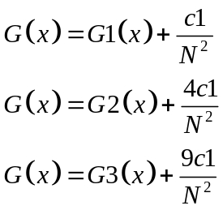 Eqn 1
Multiply the top of equation 18 by 4 and subtract the second
Eqn 2
Multiply the top by 9 and subtract the third
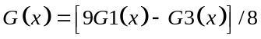Eqn 3
Multiply the middle one by 9 and the bottom by 4 and subtract
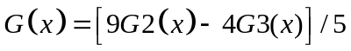Eqn 4

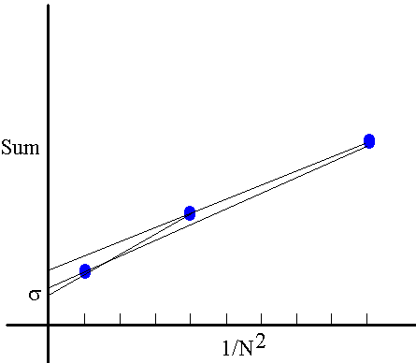
DO I=1,NP
G(I)=(4*G1(I)-G2(I))/3
GC=(9*G1(I)-G3(I))/8
GCC=(9*G1(I)-4*G3(I))/5
ERRG(I)=SQRT((G(I)-GC))**2+(G(I)-GCC)**2+(GCC-GC)**2)/3)
ENDDO

Assignment
Use the BLI in to evaluate a few test integrals between 0 and 1. Compare with analytic evaluations when possible. ..\References.htm. Plot G(x),ERRG(x), G(x)+ERRG(x), and G(x)-ERRG(x)
- ftest = x⁴
-  Integral should be 0.886226925455
-  Integral 0 to 1 should be 1.64493406685
-  error integral.
- Fresnel integral. Let fun=sin((π/2)x*x) . Integrate from 0 to 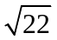 [Abramowitz and Stegun give 0.567822] This is a maximum of the integral. This is a Fresnel integral which arises in diffraction problems. It is also a chirp which arises when two stars collide.

 Integral to 1 should be 1.0471975512

