“Zapping Charlemagne’s Power Grid:
A Solar Superflare in AD 774?”
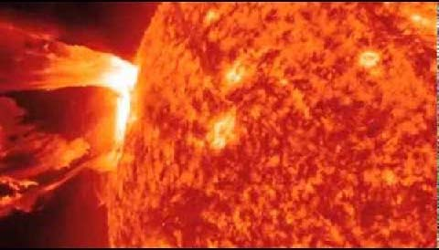

Adrian Melott, Dept. of Physics and Astronomy, University of Kansas
Abstract: Radiocarbon data indicate a jump in ¹⁴C synthesis in AD 774-775. I show that, contrary to the original publication, this is consistent with a solar proton event of fluence close to current upper limits. We can exclude very soft spectra as implying mass extinction effects which did not occur. At least seven times more powerful than the destructive 1989 “Quebec” SPE, a repeat would be disastrous for modern electromagnetic technology. Observations of Sunlike stars suggest that such events are expected on timescales of human interest.

