Homework 1.) For PHY2061, Chaps. 25, Fall 2019
Due at the beginning of class, Aug. 27
Show work on problems to get credit – the answer is not enough.
Chap. 25:
1.) (2pts) Two electrons are held a fixed distance ‘r’ apart. m_{electron}=9.11 10⁻³¹ kg
One electron is released, and under the influence of the Coulomb repulsive force from the other (fixed) electron moves away initially with an acceleration, a, = 9.8 m/s² (our old friend, ‘g’, the acceleration at the surface of the earth due to gravity.) What is ‘r’ to three significant figures? Include units.
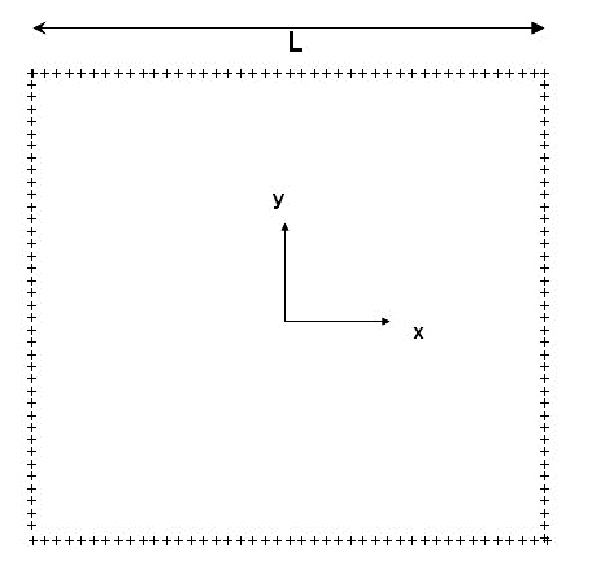
- (2pts) We discussed in class doing the integral for a square plate of charge to find F_{Coulomb}. Suppose instead of a solid square we take (in analogy to the ring of charge done in the text starting on page 577) a square ‘frame’ of charge (see picture above) in the x-y plane (0,0 is in the center of the frame) where the sides are ‘L’ long with each side having charge ‘q’ uniformly distributed. Take a point a distance ‘z’ = L/2 above the center of this frame. Write down an expression (all integrals solved please) for the Coulomb vector force (F_{x},F_{y},F_{z}) on a test charge q₀ at this point L/2 above the center of the frame of charge.

- (2pts) Two identical, small, conducting spheres are separated by a distance ‘r’, where ‘r’ is large with respect to the size of the spheres. The spheres originally have the same positive charge, and the force between them is F₁. ¼ of the charge of one sphere is now moved to the other sphere. What is the force between the spheres now, in terms of F₁ ? (Please show your work, not just an answer.)

